Android TIP Driver Installation (Android 7, 8 and 9)

The following installation instructions take place using version 3.8.0 of the SentinelBusinessServices.TipDriver.DroidDriver.APK {Android Tip Driver} being installed on a Janam XG4 using Android Version 3.8.20.1268. All future references to the version of the SBS Android Tip Driver will be reference the version as 3.8.xxxx. Your install of 3.8.xxxx (or 3.7.xxxx) will be very similar if not identical to this one depending upon the version being installed.
This procedure assumes that you have either received a SBS-CASE Tools ™ CD from Sentinel Business Services (SBS) or have downloaded it from the SBS customer portal and it contains the Android Tip Driver APK. It also assumes that a prior release of the Android Tip Driver doesn’t already exist on the device that you are about to setup. If it does already exist, please perform the Remove Existing Tip Driver section before continuing with the Installation Process.
Remove Existing TIP Driver:
To remove the existing Android Tip Driver:
- Click or drag up the Android “Search Apps” application to view the available applications on this device.
- Select “Settings” from the available applications to run.
- The next step is to locate the APPS section in the available applications. When you find it (APPS Section), click on it to start it.
- Scroll down through the APPS on the screen until you find the one named “SBS TIP Driver” application. Once you find it then click on it.
- Clicking on “Uninstall” will remove the current Android Tip Driver from the device. Before the uninstall process is started, you will be asked “Do you want to uninstall this app?”. You will respond “ok” to continue with TIP Driver removal process.
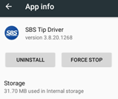
- When the uninstall is completed you will see a brief message letting you know that the app has been removed and then when you are returned to the “All Apps” screen, you will notice that the SBS Android Tip Driver has been removed.
· You should now continue with the “Installation Process” below.
Installation Process:
- To start the installation process you must copy the Android Tip Driver APK from your Windows PC to the Android device.
- Using File Explorer on the Android device, navigate to the Tip Driver APK that was downloaded to the Android device. To start the installation process click on the Android Tip Driver APK setup program.
- You may receive the following warnings (see snaps below). Click on “Continue” or “INSTALL” to continue with the installation process. Clicking on “CANCEL” will terminate the install abnormally.
- 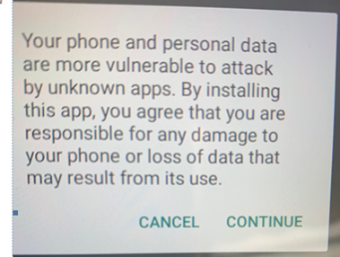

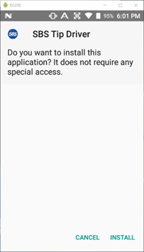
- The Android device will respond by showing you that it is installing the APK and will finally show you that the Android Tip Driver is installed.
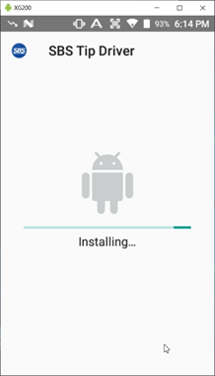
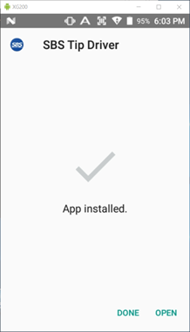
- Click “DONE” to complete the installation. The Android Tip Driver is now installed. If you search the installed applications you will see the Sentinel Android Tip Driver icon. Clicking on the icon will start the Android Tip Driver environment up.


